Supplementary Angles
# Source: AI Source: Provided by: [Data Path: Persons Table -> ID Column: 1, Name_En Column: Motasem Essam] -> From: [ChatGPT] on [7/25/2026]
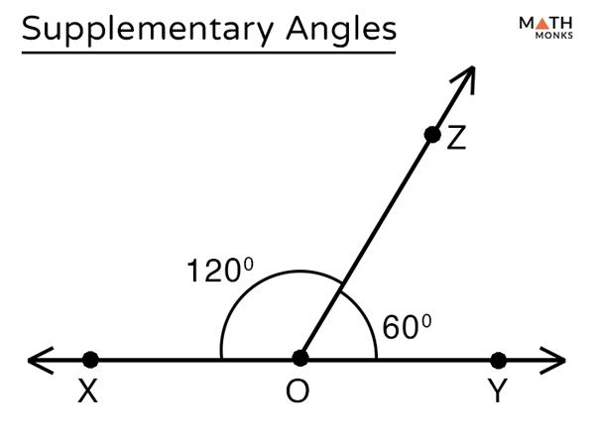
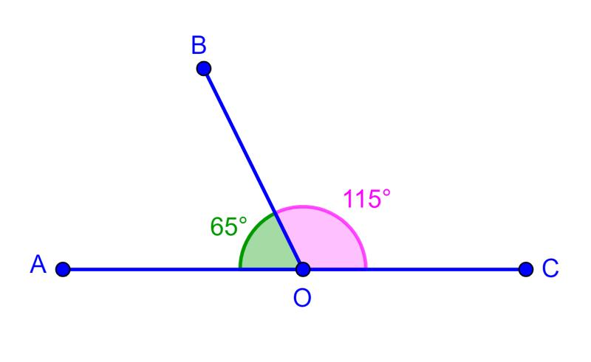
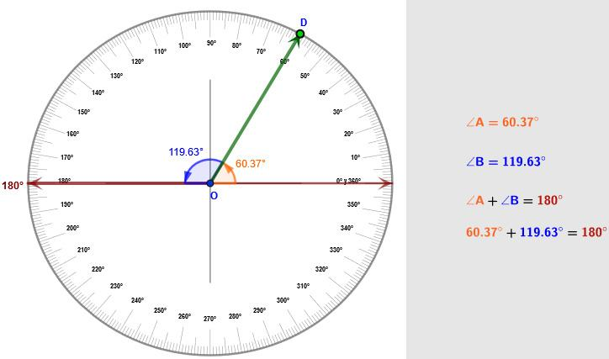
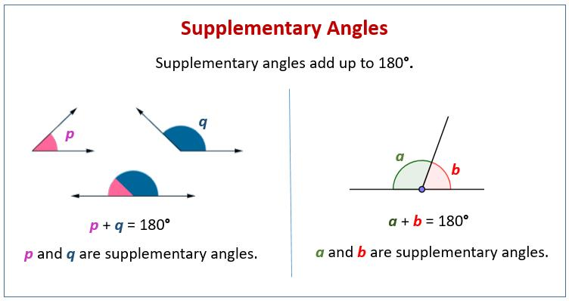
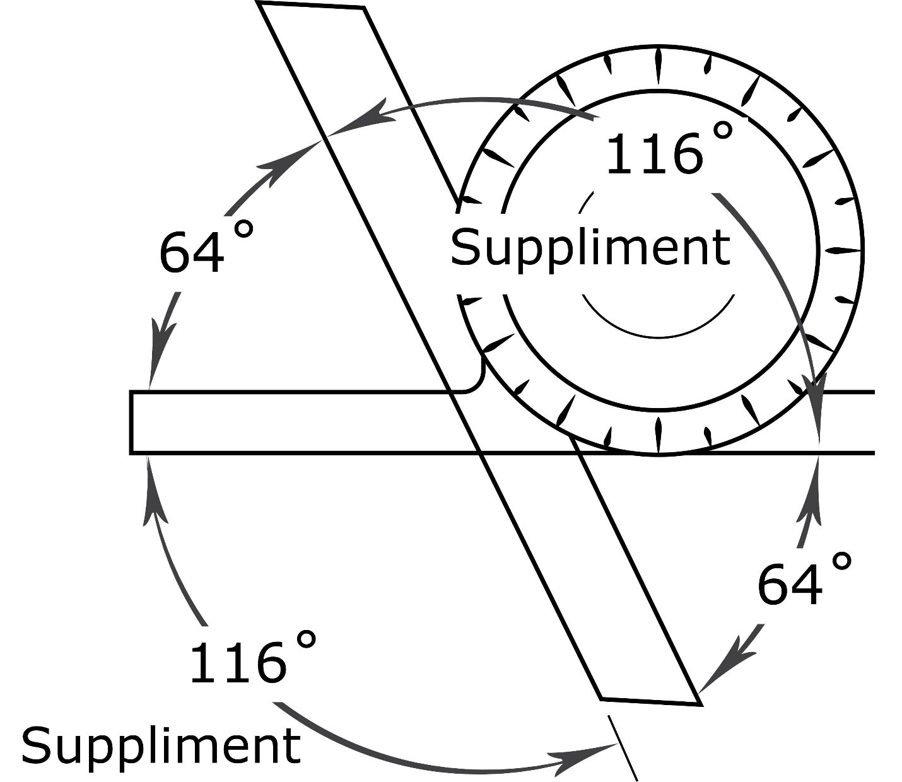
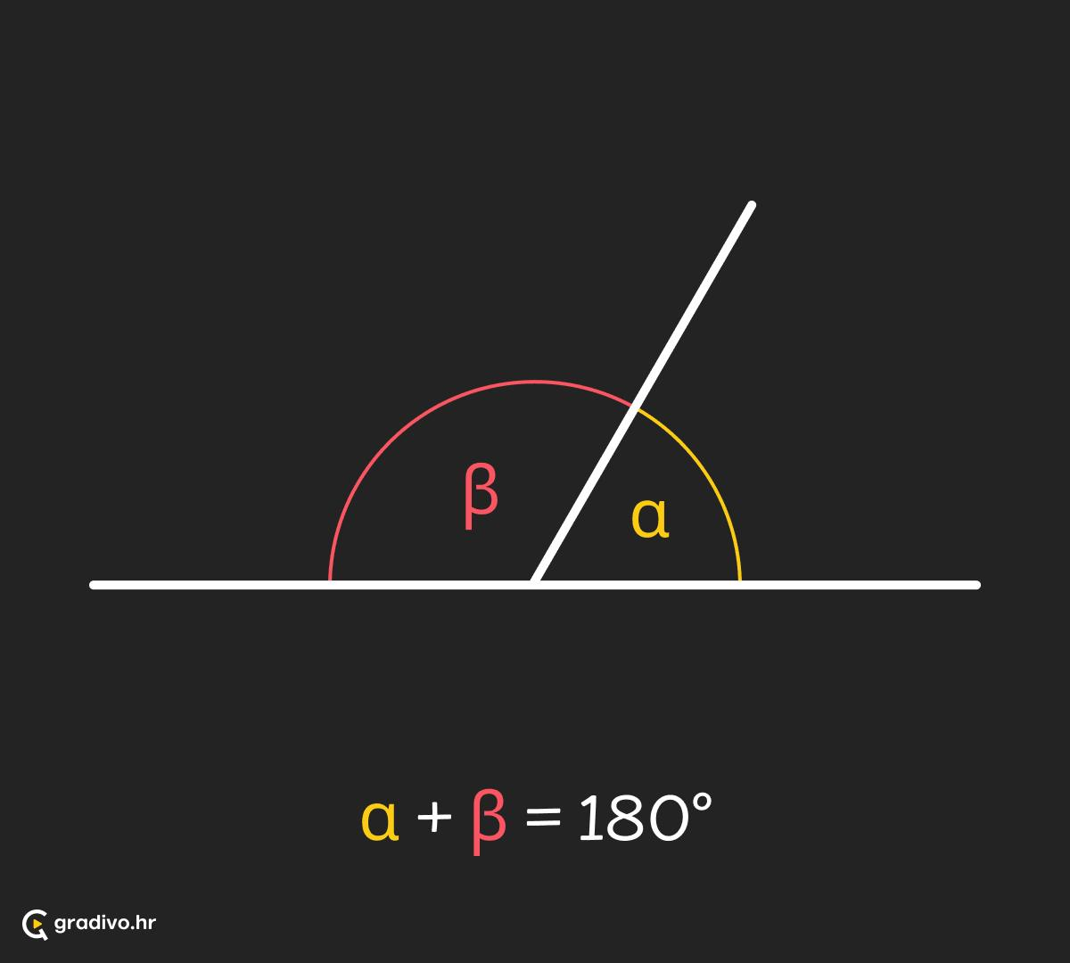

Definition
# Source: AI Source: Provided by: [Data Path: Persons Table -> ID Column: 1, Name_En Column: Motasem Essam] -> From: [ChatGPT] on [7/25/2026]
Supplementary Angles are two angles whose measures add up to exactly ${180}^{∘}$.
They may be adjacent or non-adjacent. When two supplementary angles are placed next to each other, they form a straight angle.
The relationship is defined as:
$$m∠A+m∠B={180}^{∘}$$

Characteristics
# Source: AI Source: Provided by: [Data Path: Persons Table -> ID Column: 1, Name_En Column: Motasem Essam] -> From: [ChatGPT] on [7/25/2026]
Supplementary angles:
- Have a total measure of:
$${180}^{∘}$$
- Can be adjacent or non-adjacent.
- Do not have to be equal.
- May include:
  - Acute angles.
  - Right angles.
  - Obtuse angles.
- When adjacent, they form a straight line.

Illustration

Adjacent Supplementary Angles (Linear Pair)
# Source: AI Source: Provided by: [Data Path: Persons Table -> ID Column: 1, Name_En Column: Motasem Essam] -> From: [ChatGPT] on [7/25/2026]
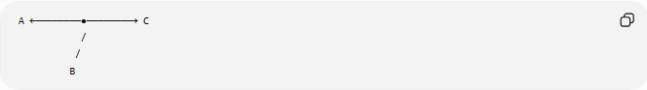
A ←────────●────────→ C
/
/
B
The two angles share a common side and together form:
$${180}^{∘}$$
Example:
$${120}^{∘}+{60}^{∘}={180}^{∘}$$

Non-Adjacent Supplementary Angles
# Source: AI Source: Provided by: [Data Path: Persons Table -> ID Column: 1, Name_En Column: Motasem Essam] -> From: [ChatGPT] on [7/25/2026]
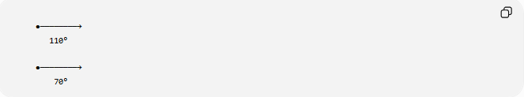
●────────→
110°

●────────→
70°
They are supplementary because:
$${110}^{∘}+{70}^{∘}={180}^{∘}$$

Mathematical Representation
# Source: AI Source: Provided by: [Data Path: Persons Table -> ID Column: 1, Name_En Column: Motasem Essam] -> From: [ChatGPT] on [7/25/2026]
If two angles are:
$$∠A$$
and
$$∠B$$
then they are supplementary when:
$$m∠A+m∠B={180}^{∘}$$
In radians:
$$θ_{1}+θ_{2}=π$$

Examples
# Source: AI Source: Provided by: [Data Path: Persons Table -> ID Column: 1, Name_En Column: Motasem Essam] -> From: [ChatGPT] on [7/25/2026]
Example 1
Given:
$$∠A={40}^{∘}$$
Find its supplement:
$${180}^{∘}-{40}^{∘}={140}^{∘}$$
Therefore:
$$∠B={140}^{∘}$$

Example 2
Given:
$$∠A={95}^{∘}$$
The supplementary angle is:
$${180}^{∘}-{95}^{∘}={85}^{∘}$$

Common Supplementary Angle Pairs
# Source: AI Source: Provided by: [Data Path: Persons Table -> ID Column: 1, Name_En Column: Motasem Essam] -> From: [ChatGPT] on [7/25/2026]
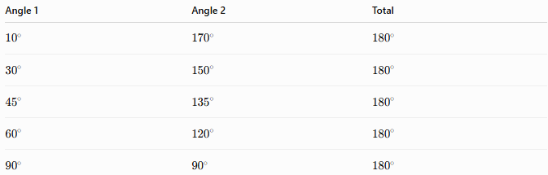
Angle 1 | Angle 2 | Total
$${10}^{∘}$$ | $${170}^{∘}$$ | $${180}^{∘}$$
$${30}^{∘}$$ | $${150}^{∘}$$ | $${180}^{∘}$$
$${45}^{∘}$$ | $${135}^{∘}$$ | $${180}^{∘}$$
$${60}^{∘}$$ | $${120}^{∘}$$ | $${180}^{∘}$$
$${90}^{∘}$$ | $${90}^{∘}$$ | $${180}^{∘}$$

Properties of Supplementary Angles
# Source: AI Source: Provided by: [Data Path: Persons Table -> ID Column: 1, Name_En Column: Motasem Essam] -> From: [ChatGPT] on [7/25/2026]
1. Sum Property
The defining property:
$$θ_{1}+θ_{2}={180}^{∘}$$

2. Supplement of an Angle
For an angle:
$$θ$$
its supplement is:
$${180}^{∘}-θ$$
Example:
$${180}^{∘}-{75}^{∘}={105}^{∘}$$

3. Relationship with Straight Angles
When two supplementary angles are adjacent:
$$∠A+∠B={180}^{∘}$$
they form a straight angle.

4. Equal Supplementary Angles
If two supplementary angles are equal:
$$θ+θ={180}^{∘}$$
then:
$$2θ={180}^{∘}$$
$$θ={90}^{∘}$$
Therefore, two equal supplementary angles are both right angles.

Types of Supplementary Angle Pairs
# Source: AI Source: Provided by: [Data Path: Persons Table -> ID Column: 1, Name_En Column: Motasem Essam] -> From: [ChatGPT] on [7/25/2026]
1. Acute + Obtuse
Example:
$${40}^{∘}+{140}^{∘}={180}^{∘}$$

2. Right + Right
Example:
$${90}^{∘}+{90}^{∘}={180}^{∘}$$

3. Obtuse + Acute
Example:
$${110}^{∘}+{70}^{∘}={180}^{∘}$$

Supplementary Angles in Geometry

Linear Pair
# Source: AI Source: Provided by: [Data Path: Persons Table -> ID Column: 1, Name_En Column: Motasem Essam] -> From: [ChatGPT] on [7/25/2026]
A linear pair is a special type of supplementary angles where:
- They are adjacent.
- Their non-common sides form a straight line.
Example:
$$∠AOB+∠BOC={180}^{∘}$$

Parallel Lines and Transversals
# Source: AI Source: Provided by: [Data Path: Persons Table -> ID Column: 1, Name_En Column: Motasem Essam] -> From: [ChatGPT] on [7/25/2026]
When a transversal crosses parallel lines, many angle pairs are supplementary:
Same-Side Interior Angles
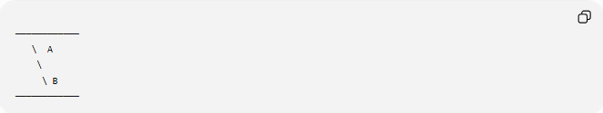
────────────
\ A
\
\ B
────────────
Relationship:
$$A+B={180}^{∘}$$

Real-World Examples
# Source: AI Source: Provided by: [Data Path: Persons Table -> ID Column: 1, Name_En Column: Motasem Essam] -> From: [ChatGPT] on [7/25/2026]
Supplementary angles appear in:
- A straight road divided into two directions.
- A straight ruler.
- A flat surface edge.
- Open scissors forming a straight position.
- Intersections of roads.
- Architectural structures.
- Engineering drawings.

Applications
# Source: AI Source: Provided by: [Data Path: Persons Table -> ID Column: 1, Name_En Column: Motasem Essam] -> From: [ChatGPT] on [7/25/2026]
Supplementary angles are used in:
- Plane Geometry
- Coordinate Geometry
- Trigonometry
- Engineering
- Architecture
- Construction
- Surveying
- CAD (Computer-Aided Design)
- Robotics
- Computer Graphics

Advantages
# Source: AI Source: Provided by: [Data Path: Persons Table -> ID Column: 1, Name_En Column: Motasem Essam] -> From: [ChatGPT] on [7/25/2026]
Studying supplementary angles helps to:
- Find missing angle measures.
- Solve geometry problems.
- Understand straight lines.
- Analyze parallel-line relationships.
- Build geometric constructions.

Limitations
# Source: AI Source: Provided by: [Data Path: Persons Table -> ID Column: 1, Name_En Column: Motasem Essam] -> From: [ChatGPT] on [7/25/2026]
Supplementary angles:
- Must add exactly:
$${180}^{∘}$$
- Are not supplementary if their sum is:
  - ${90}^{∘}$
  - ${360}^{∘}$
  - Any value other than ${180}^{∘}$

Comparison with Other Angle Relationships
# Source: AI Source: Provided by: [Data Path: Persons Table -> ID Column: 1, Name_En Column: Motasem Essam] -> From: [ChatGPT] on [7/25/2026]
Relationship | Condition
Supplementary Angles | Sum $={180}^{∘}$
Complementary Angles | Sum $={90}^{∘}$
Adjacent Angles | Share vertex and one side
Vertical Angles | Opposite angles, equal measure
Congruent Angles | Same measure

Key Points
# Source: AI Source: Provided by: [Data Path: Persons Table -> ID Column: 1, Name_En Column: Motasem Essam] -> From: [ChatGPT] on [7/25/2026]
- Supplementary Angles have a sum of:
$${180}^{∘}$$
- Formula:
$$m∠A+m∠B={180}^{∘}$$
- Adjacent supplementary angles form a straight angle.
- The supplement of an angle is:
$${180}^{∘}-θ$$
- Two equal supplementary angles are both:
$${90}^{∘}$$

Conclusion
# Source: AI Source: Provided by: [Data Path: Persons Table -> ID Column: 1, Name_En Column: Motasem Essam] -> From: [ChatGPT] on [7/25/2026]
Supplementary Angles are pairs of angles whose measures add up to exactly ${180}^{∘}$. They are fundamental in geometry because they describe straight-line relationships, linear pairs, and angle interactions created by intersecting and parallel lines. Supplementary angles are widely used in plane geometry, coordinate geometry, trigonometry, engineering, architecture, construction, surveying, CAD, robotics, and computer graphics to analyze straight paths, rotations, and geometric structures.

